From: https://medium.com/@marisol.nostromo/i-was-suspended-by-twitter-for-what-4ed8be94858d
On:

I was suspended by Twitter for what?
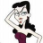
Marisol Nostromo
Following
Jul 1 · 5 min read
Updated 8/4/2020

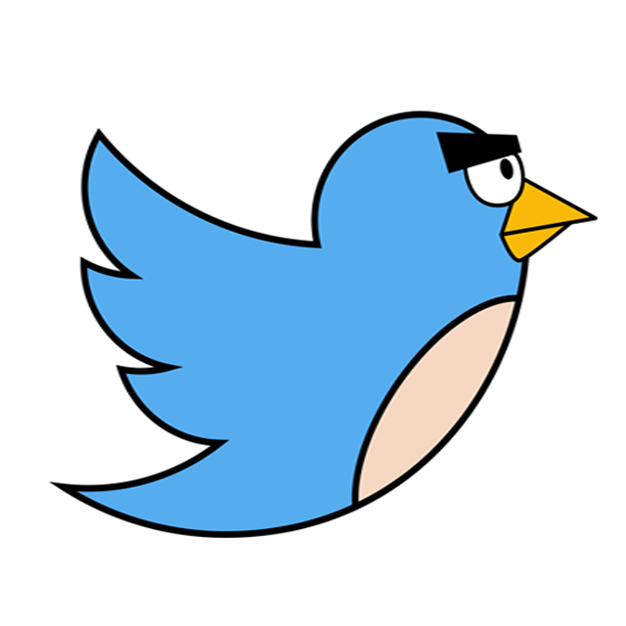
On the morning of June 30, 2020, I opened my Twitter account and received a notice that it had been suspended. Following a link that promised to lead me an explanation, I learned that I had been suspended for:

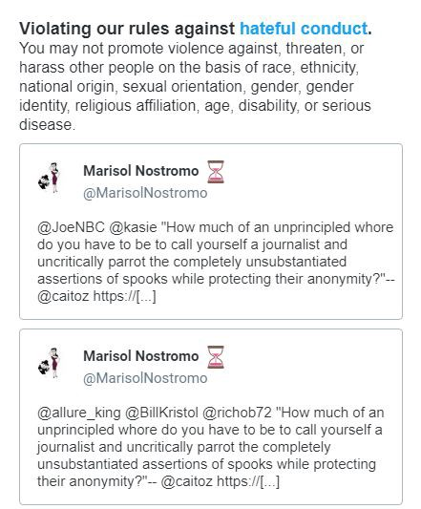
“…Violating our rules against hateful conduct. You may not promote violence against, threaten, or harass other people on the basis of race, ethnicity, national origin, sexual orientation, gender, gender identity, religious affiliation, age, disability, or serious disease.”
The notice provided copies of the offending tweet, which may be seen to the left. Please note that nowhere in my tweet is there any reference to a race, ethnicity, national origin, sexual orientation, gender, gender identity, religious affiliation, age, disability, or serious disease. Please note also that there is no promotion of violence against other people, nor any threats or harassment of other people. In short, there was absolutely nothing in my tweet to violate the cited Twitter rule.
Attached to my tweet was a link to this excellent article by Ray McGovern of Veteran Intelligence Professionals for Sanity, an organization of whistle-blowers from the various U.S. intelligence agencies. Mr. McGovern was a CIA analyst from 1963 to 1990, and in the 1980s chaired National Intelligence Estimates and prepared the President’s Daily Brief. He now writes for Consortium News and other alternative press sites, and I find his analysis to be consistently lucid and on-target.
The portion of my tweet which appears in quotation marks is from another excellent article by the Australian commentator Caitlin Johnstone, which is also quoted by Mr. McGovern at the end of his own article. Although I sometimes disagree with Ms. Johnstone’s more psychedelic offerings, she has demonstrated many times that when she takes aim at the courtesans of the media and their neocon clients, she exposes their corruption with brilliant precision.
Needless to say, I am not the only user of social media to be subjected to some form of censorship. Neocons have been vociferously demanding censorship of social media with growing shrillness over the past few years. Of course, they don’t call it censorship, unless it is being done by a nation on their very extensive enemies list. They market domestic censorship very shrewdly, appealing to the specific prejudices of whatever target audience they are trying to get riled up.
Consequently, groups and individuals are being suspended, demonetized, or deplatformed with increasing frequency. This is happening to voices from a wide assortment of ideological niches, generally the ones with the most vocal and crafty opponents — the squeaky wheel gets the grease, unless your viewpoint is significant enough to get the secret police agencies involved, in which case different rules apply.

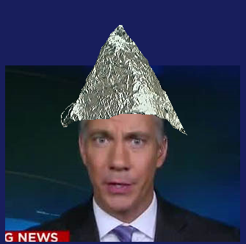
For many Americans who have come to distrust the corporate media, social media provide an alternative venue for the circulation of news, much of it also fake, but without the filtering system that protects consumers of CNN, MSNBC, the New York Times, and other outlets from exposure to information that lacks the neocon imprimatur. The neocon pundits such as David Frum or Jim Sciutto are hyperactive on Twitter, attempting to drown out opposing views, but nothing beats the prospect of simply silencing the nonconformists.
Interestingly, this controversy has drawn the attention of President Trump, who, for better or worse, had hit upon the tactic of using Twitter to communicate with his base, in order to evade the hostile attentions of the corporate media. On May 28, 2020, Trump issued an Executive Order on Preventing Online Censorship, which is tailored for the purposes of protecting himself and his allies and which may possibly benefit many others. Trump’s critics were outraged, and regardless of which side you are rooting for, it is clearly going to be a monumental task to devise a fair system of rules when most parties are hoping to silence their opponents, while simultaneously getting their own word out as widely as possible.

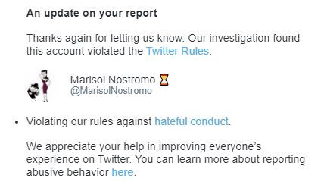
Meanwhile, in my own case, I have found that attempting to communicate with Twitter about my suspension is a Kafkaesque proposition. It appears to me that all responses to my queries have been automated, and the AI hordes which I imagine Twitter uses for this purpose are clearly confused, since they keep sending me notifications in which they congratulate me for having turned myself in.
To celebrate Independence Day, Twitter sent me an update to my case on July 4. Apparently I am no longer accused of violating Twitter’s rules on hateful conduct. Now I am violating Twitter’s Terms of Service. I was looking forward to finding out how I did that.

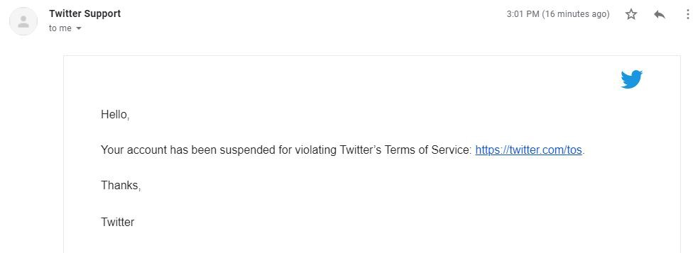
Clearly, the trigger for this episode was the original cited tweet, which cast aspersions on the latest installment of #Russiagate, that being the tales of Commie conspirators passing money to the Taliban as an incentive for them to fight the same American army of occupation which they have been fighting for the past two decades. This new update was being flogged in the press with special vituperation, due to the fact that Trump was making a new attempt to withdraw those American troops.
Since my tweet cannot be credibly found in violation of Twitter’s hateful conduct rules, I am going to assume here that the person(s) who complained against me has enough political juice that Twitter took action against me without a plausible rationale, and is now engaged in a bit of CYA with the new “Terms of Service violation” approach.

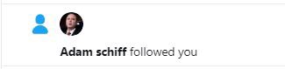
A month has gone by, and it is becoming increasing clear that Twitter has no intention of responding to my requests for an explanation of my purported “Terms of Service violation.” I would say that on the whole I have been a solid, respectable citizen of the Twitterverse. I may have occasionally re-tweeted a meme that likened Special Representative for Venezuela Elliott Abrams to Satan, but who hasn’t? The rules don’t really matter; the Powers That Be are busily imposing their own version of order upon the once rambunctiously free and open internet.

46

1
- Censorship
- Twitter
- Neoconservatism
- Trump
- Internet Censorship

46 claps

1 response
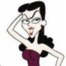
WRITTEN BY

Marisol Nostromo
Following

Marisol is an arts aficionado and a social media habitué.

